UID EX 9
NAME: ARIFA H ROLL NO: 240701047
AIM:
The aim is to design a student registration form that validates input fields such as name, age, password,
and confirm password, and displays appropriate error messages using HTML, CSS, and JavaScript.

PROCEDURE:

Step 1:
Setting Up the HTML Form
Start by creating an HTML form with input fields for name, age, password, and confirm password.

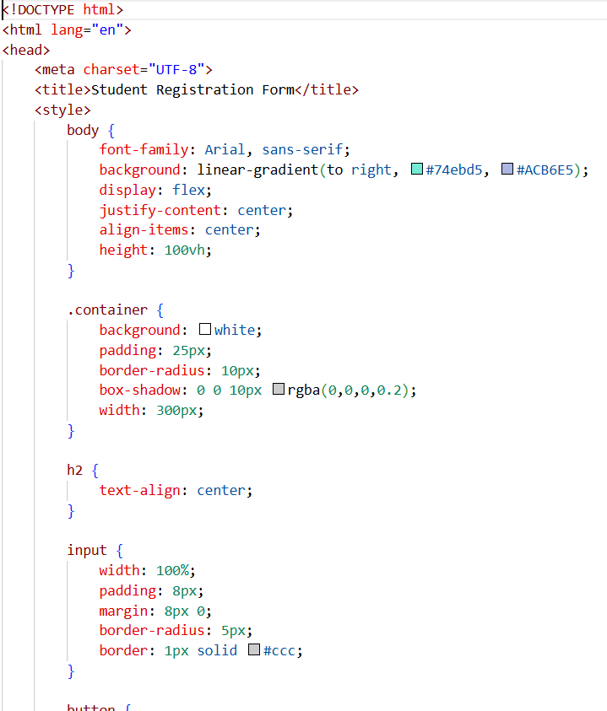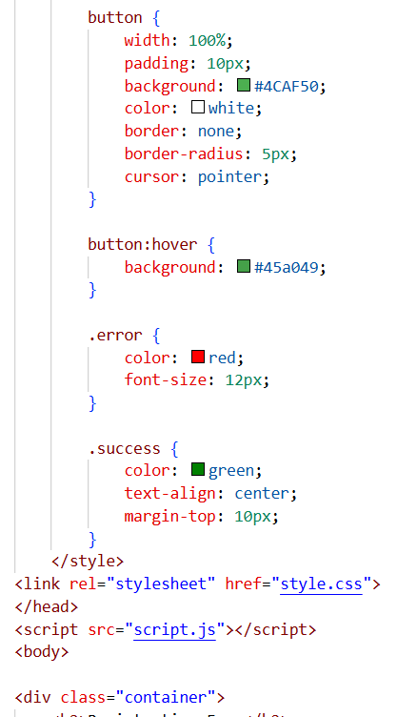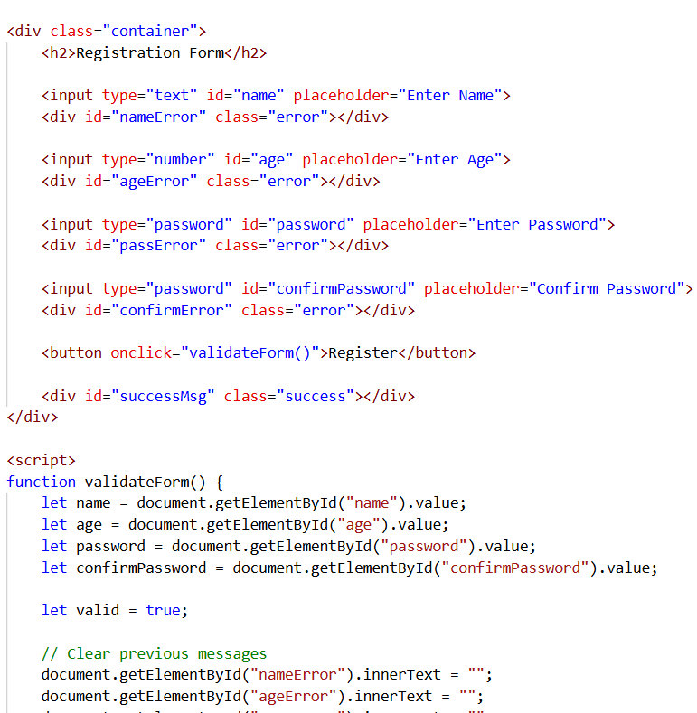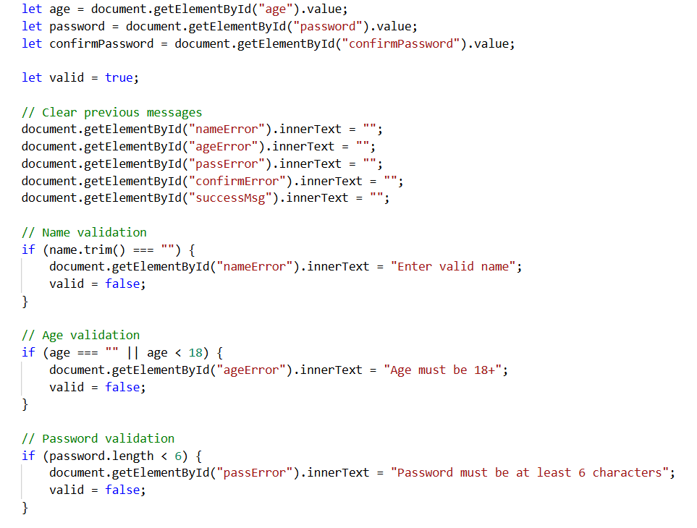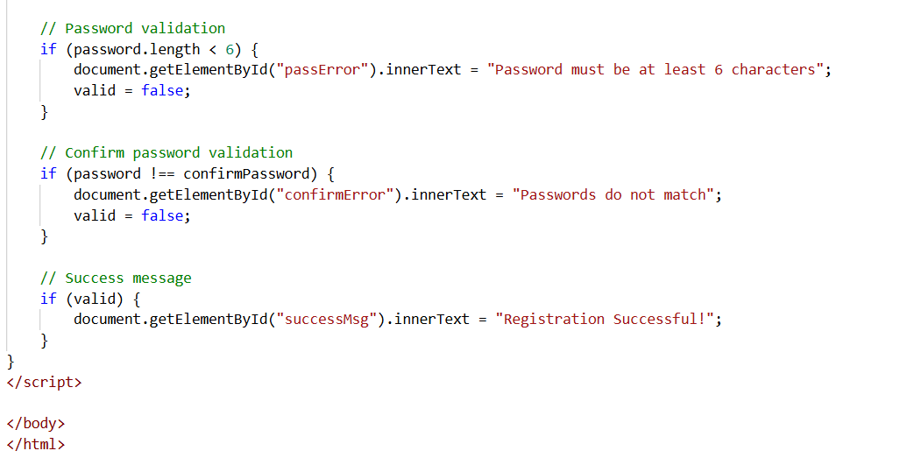

Step 2:
Styling the Form with CSS
Next, add some basic styling to make the form look neat and user-friendly. 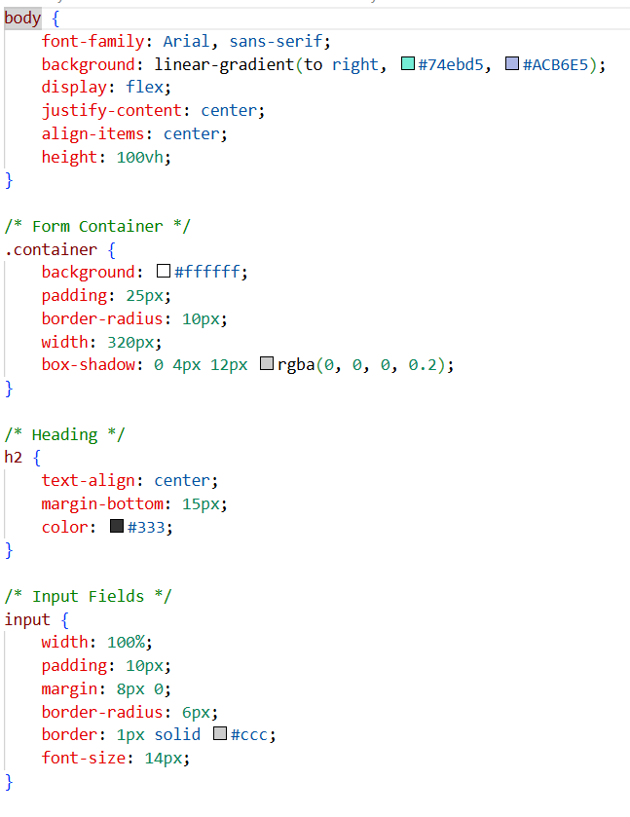
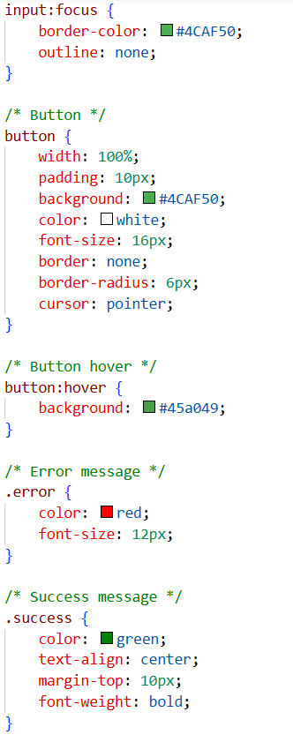

Adding JavaScript for Validation

Finally, add JavaScript to validate the input fields and display error messages.
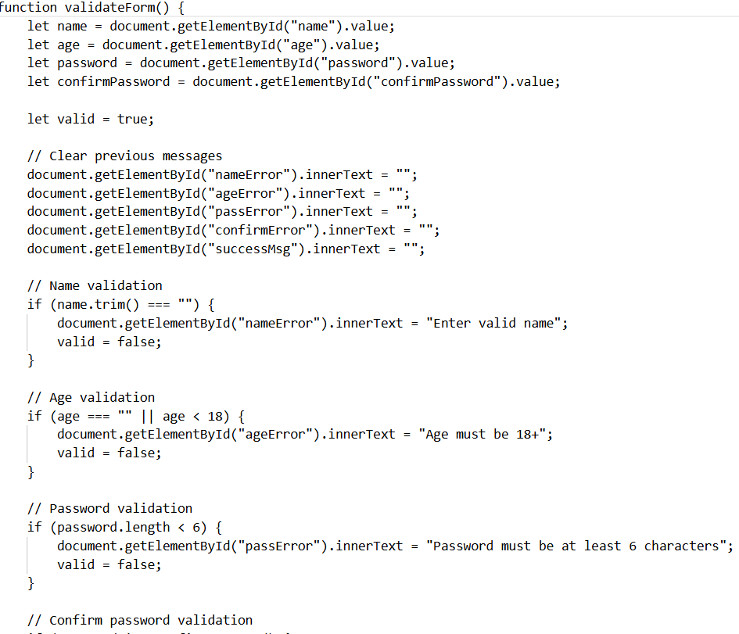
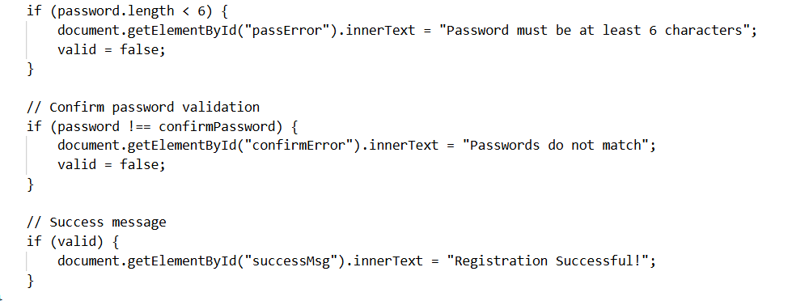

OUTPUT

For valid input:
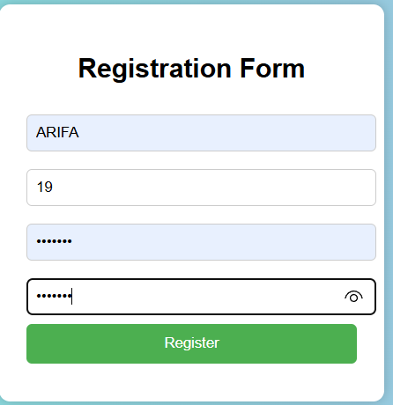

Error message for invalid age:

